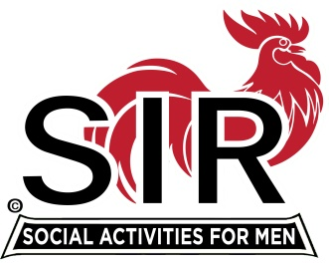
Las Trampas Branch 116
BEC Meeting Agenda
April 20th. , 2020, 9:00 AM
The Mission of SIR is to enhance the lives of our members through fun activities, events and luncheons – while making friends for life.

09:00 Coffee Available !!!

- Call to order; Secretary confirm a quorum
- Secretary – Fred Schafer – Approval of March minutes
- Treasurer – Alan Fitzgerald
- Member issues: Mike Schneider
- Activities report: Fred Wachowicz
5) Big SIR report – Michael
- Virtual mtgs (Davy Harris)
- Member phone calls (Roger Craig)
- Vista Print: SIR ‘Gear’. Free shipping .https://files.constantcontact.com/686f3f04701/4959f734-ece0-4bc1-9ea2-e44d94b13ba5.jpg
6) Little SIR report
- AOB

- Date for next meeting?

